Name: Farhan Mohamed Ibrahim
Date: 22 September 2026
Course/Class Title: Practical Development Setup: Flutter, Python, MySQL, and VS Code Integration.

Section 1: Task 1 - Flutter & Dart Setup
Flutter verification

Doctor summary (to see all details, run flutter doctor -v):
[√] Flutter (Channel stable, 3.47.4, on Microsoft Windows [Version 10.0.22621.4317], locale en-KE)
[√] Windows Version (11 Pro 64-bit, 22H2, 2009)
[√] Android toolchain - develop for Android devices (Android SDK version 36.0.0)
[√] Chrome - develop for the web
[√] Visual Studio - develop Windows apps (Visual Studio Community 2026 18.10.1)
[√] Connected device (3 available)
[√] Network resources

• No issues found!

Flutter target devices

C:\Users\user\my_first_app>flutter devices
Found 3 connected devices:
Windows (desktop) • windows • windows-x64 • Microsoft Windows [Version 10.0.22621.4317]
Chrome (web) • chrome • web-javascript • Google Chrome 153.0.8010.48
Edge (web) • edge • web-javascript • Microsoft Edge 153.0.4234.48

Run "flutter emulators" to list and start any available device emulators.

If you expected another device to be detected, please run "flutter doctor" to diagnose potential issues. You may also try increasing
the time to wait for connected devices with the "--device-timeout" flag. Visit https://flutter.dev/setup/ for troubleshooting tips.

HOT RELOAD AND HOT RESTART
Hot Reload allows a developer to apply code changes to a running Flutter application without completely restarting the application. It generally preserves the current application state, making it useful for quickly testing changes to the user interface, layout, styling, or other parts of the code.
Hot Restart completely restarts the Flutter application and clears the current application state. It is useful when changes require the application to start from the beginning or when Hot Reload does not properly reflect the changes.
In simple terms, Hot Reload is used to quickly see code changes while keeping the current state, whereas Hot Restart starts the application again from scratch.

Section 2: Task 2 - MySQL Database Management
1. SQL Script
The commands used are:
CREATE DATABASE school;

USE school;

CREATE TABLE students (
id INT AUTO_INCREMENT PRIMARY KEY,
name VARCHAR(100),
email VARCHAR(150) UNIQUE,
enrolled_on DATE
);
INSERT INTO students (name, email, enrolled_on)
VALUES
('Ahmed Hassan', 'ahmed.hassan@example.com', '2026-09-22'),
('Amina Yusuf', 'amina.yusuf@example.com', '2026-09-22');
SELECT * FROM students;
The Results received:
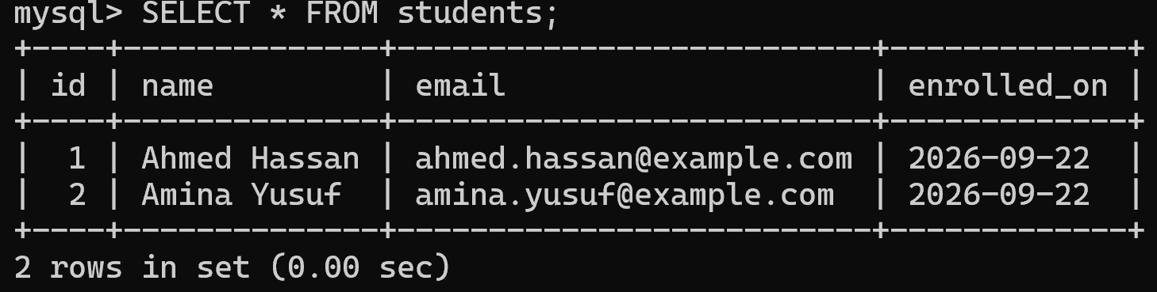

Security Reflection
Using the MySQL root account for a direct application backend connection is poor security practice because root has extensive privileges over the database server. If the application's credentials were exposed or compromised, an attacker could potentially access, modify, or delete data beyond what the application actually needs.
A better approach is to create a dedicated application account and follow the principle of least privilege. For this project, I created a user called school_app and granted it only SELECT, INSERT, UPDATE, and DELETE privileges on the school database.
The SQL commands used were:
CREATE USER 'school_app'@'localhost' IDENTIFIED BY 'SchoolApp@2026!';

GRANT SELECT, INSERT, UPDATE, DELETE
ON school.* TO 'school_app'@'localhost';

SHOW GRANTS FOR 'school_app'@'localhost';

The SHOW GRANTS command was used to verify that the account received only the intended permissions on the school database.

Section 3: Task 3 - Python Virtual Environment

Python Environment and Dependency Isolation
A separate Python virtual environment was created to keep the project's dependencies isolated from the system-wide Python installation. The requests package was installed inside the virtual environment and the installed packages were verified using pip list. Finally, the environment was exported to a requirements.txt file.

Commands Used
mkdir python_setup_lab
cd python_setup_lab
python -m venv venv
venv\Scripts\activate
pip install requests
pip list
pip freeze > requirements.txt

Verification
The virtual environment was successfully activated, as shown by the (venv) prefix in the terminal. The pip list command confirmed that the requests package and its dependencies were installed successfully. The pip freeze > requirements.txt command successfully created the requirements.txt file inside the python_setup_lab directory.
Section 4: Task 4 - VS Code Workspace Screenshot
VS Code was configured with the required Flutter, Dart, Python, Pylance, and MySQL extensions. The Python virtual environment (venv) was activated and configured for the python_setup_lab project.
The screenshot below shows the installed extensions and the active Python virtual environment in the integrated terminal.wait

